Nonomino

From Wikipedia, the free encyclopedia

Jump to navigation Jump to search
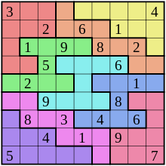
A nonomino or Jigsaw Sudoku puzzle, as seen in the Sunday Telegraph
A nonomino (or 9-omino) is a polyomino of order 9, that is, a polygon in the plane made of 9 equal-sized squares connected edge-to-edge.[1] The name of this type of figure is formed with the prefix non(a)-. When rotations and reflections are not considered to be distinct shapes, there are 1,285 different free nonominoes. When reflections are considered distinct, there are 2,500 one-sided nonominoes. When rotations are also considered distinct, there are 9,910 fixed nonominoes.[2]

Symmetry
The 1,285 free nonominoes can be classified according to their symmetry groups:[2]
- 1,196 nonominoes have no symmetry. Their symmetry group consists only of the identity mapping.
- 38 nonominoes have an axis of reflection symmetry aligned with the gridlines. Their symmetry group has two elements, the identity and the reflection in a line parallel to the sides of the squares.
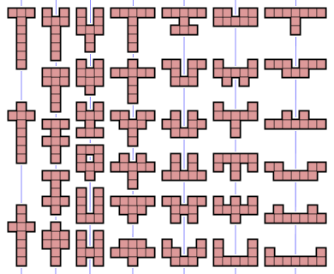
- 26 nonominoes have an axis of reflection symmetry at 45° to the gridlines. Their symmetry group has two elements, the identity and a diagonal reflection.
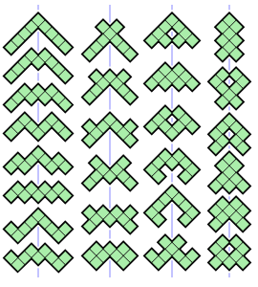
- 19 nonominoes have point symmetry, also known as rotational symmetry of order 2. Their symmetry group has two elements, the identity and the 180° rotation.
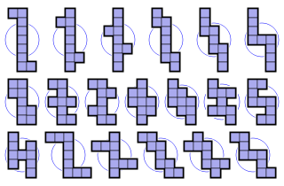
- 4 nonominoes have two axes of reflection symmetry, both aligned with the gridlines. Their symmetry group has four elements, the identity, two reflections and the 180° rotation. It is the dihedral group of order 2, also known as the Klein four-group.
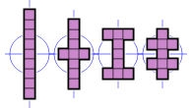
- 2 nonominoes have four axes of reflection symmetry, aligned with the gridlines and the diagonals, and rotational symmetry of order 4. Their symmetry group, the dihedral group of order 4, has eight elements.
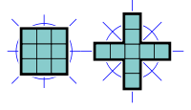
Unlike octominoes, there are no nonominoes with rotational symmetry of order 4 or with two axes of reflection symmetry aligned with the diagonals.
If reflections of a nonomino are considered distinct, as they are with one-sided nonominoes, then the first and fourth categories above double in size, resulting in an extra 1,215 nonominoes for a total of 2,500. If rotations are also considered distinct, then the nonominoes from the first category count eightfold, the ones from the next three categories count fourfold, the ones from the fifth category count twice, and the ones from the last category count only once. This results in 1,196 × 8 + (38+26+19) × 4 + 4 × 2 + 2 = 9,910 fixed nonominoes.

Packing and tiling
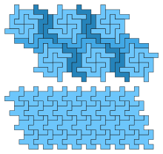
37 nonominoes have holes.[3][4] Therefore a complete set cannot be packed into a rectangle and some admit no tilings. However, 1050 free nonominoes (all but 235) do admit tilings;[5] of the tiling nonominoes, all but two of them form a patch of at least one tile satisfying the Conway criterion, the two exceptions shown to the right. This is the lowest order of polyomino for which such exceptions exist.[6]
One nonomino has a two-square hole (second rightmost in the top row) and is the smallest polyomino with such a hole. 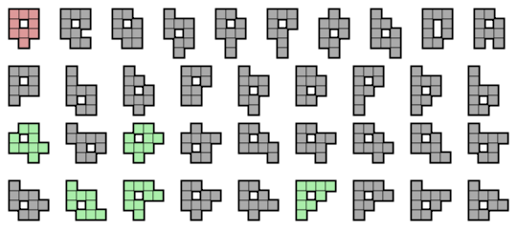

References

- Golomb, Solomon W. (1994). Polyominoes (2nd ed.). Princeton, New Jersey: Princeton University Press. ISBN 0-691-02444-8.
- Redelmeier, D. Hugh (1981). "Counting polyominoes: yet another attack". Discrete Mathematics. 36: 191–203. doi:10.1016/0012-365X(81)90237-5.
- Weisstein, Eric W. "Polyomino". MathWorld.
- Sloane, N. J. A. (ed.). "Sequence A001419 (Number of n-celled polyominoes with holes)". The On-Line Encyclopedia of Integer Sequences. OEIS Foundation.
- Rawsthorne, Daniel A. (1988). "Tiling complexity of small n-ominoes (n<10)". Discrete Mathematics. 70: 71–75. doi:10.1016/0012-365X(88)90081-7.
- Rhoads, Glenn C. (2005). "Planar tilings by polyominoes, polyhexes, and polyiamonds". Journal of Computational and Applied Mathematics. 174 (2): 329–353. doi:10.1016/j.cam.2004.05.002.

- v
- t
- e
Polyforms
Polyominoes | - Polyomino  - Domino  - Tromino  - Tetromino  - Pentomino  - Hexomino  - Heptomino  - Octomino  - Nonomino  - Decomino
Higher dimensions | - Polyominoid  - Polycube
Others | - Polyabolo  - Polydrafter  - Polyhex  - Polyiamond  - Pseudo-polyomino  - Polystick
Games and puzzles | - Blokus  - Soma cube  - Snake cube  - Tangram  - Tantrix  - Tetris
WikiProject Portal

Categories:
- Polyforms

Navigation menu

- Not logged in
- Talk
- Contributions
- Create account
- Log in

- Article
- Talk

- Read
- Edit
- View history

Search

- Main page
- Contents
- Featured content
- Current events
- Random article
- Donate to Wikipedia
- Wikipedia store

Interaction
- Help
- About Wikipedia
- Community portal
- Recent changes
- Contact page

Tools
- What links here
- Related changes
- Upload file
- Special pages
- Permanent link
- Page information
- Wikidata item
- Cite this page

Print/export
- Create a book
- Download as PDF
- Printable version

In other projects
- Wikimedia Commons

Languages
- Esperanto
- Português
- Русский
- Slovenščina
- 中文
Edit links
- This page was last edited on 26 March 2018, at 21:23 (UTC).
- Text is available under the Creative Commons Attribution-ShareAlike License; additional terms may apply. By using this site, you agree to the Terms of Use and Privacy Policy. Wikipedia® is a registered trademark of the Wikimedia Foundation, Inc., a non-profit organization.
- Privacy policy
- About Wikipedia
- Disclaimers
- Contact Wikipedia
- Developers
- Cookie statement
- Mobile view
- Enable previews

